Amber Burrell

July 21, 2020

Assignment #3

Penguin Bar Graphs

**Prompt #1**

|  |  |  |
| --- | --- | --- |
|  | Prompt 1 |  |
| Variables | Class | Levels |
| Sex | Factors | Female, Male |
| Body mass | Integer | NULL |
| Species | Factor | Adelie, Chinstrap, Gentoo |
| Island | Factor | Biscoe, Dream, Torgersen |
| Flip. Len. | Integer | NULL |
| Bill Len. | Numeric | NULL |
| Bill Depth | Numeric | NULL |

For the items that have something other than factors in "Class" they result in Null or not applicable.

**Prompt 2**

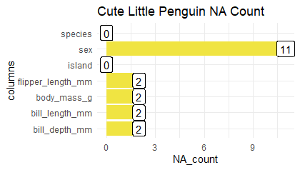

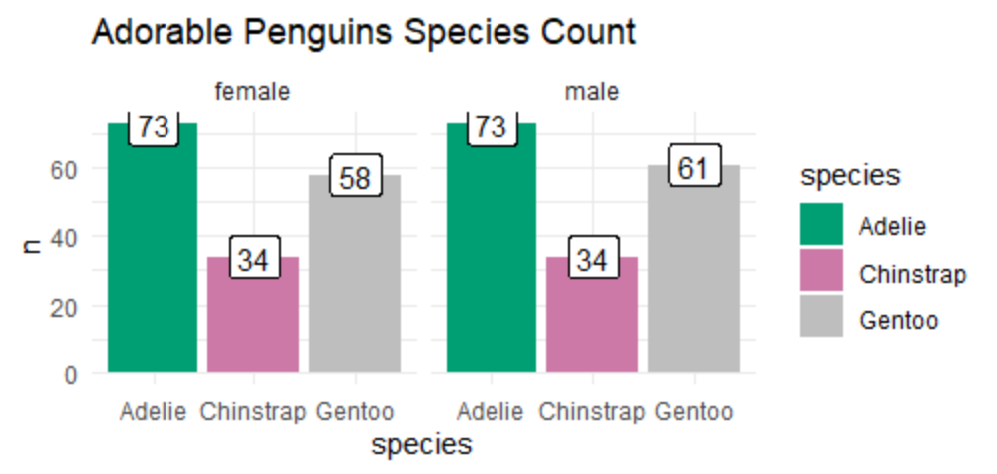

By putting the code in it was able to separate the data between male and females as well as the difference penguin species. There is approximately the same amount of female and male penguins. There are also very little Chinstrap penguins to be found for both male and females.

**Prompt #3**

*Three Variables*

|  |  |  |  |  |  |  |  |  |  |
| --- | --- | --- | --- | --- | --- | --- | --- | --- | --- |
|  | Adelie Species | Chinstrap Species | Gentoo Species | Biscoe island | Dream Island | Torgersen Island | Females | Males | N/A Sex |
| # Penguins | 152 | 68 | 124 | 168 | 124 | 52 | 165 | 168 | 11 |

*Output for the remain variables*

|  |  |  |  |  |  |  |  |
| --- | --- | --- | --- | --- | --- | --- | --- |
|  |  | Prompt 3 |  |  |  |  |  |
| Variables | Min | 1st Quart | Median | Mean | 3rd Quart | Max. | NA's |
| Flipper Length | 172 | 190 | 197 | 200.9 | 213 | 231 | 2 |
| Body Mass | 2700 | 3550 | 4050 | 4202 | 4750 | 6300 | 2 |
| Bill Length | 32.1 | 39.23 | 44.45 | 43.92 | 48.5 | 59.6 | 2 |

**Prompt 4**

1. I learned that it is easier and more sufficient to read bar graph and the scatterplot. It is more organized and separated to read.
2. Research Questions
3. Group: Why are Chinstrap penguins only found on dream island?
4. Why are there significantly more Adelie penguins in both sexes of all three islands combined?